Mohamed Fahim El-Hewie

mohamed.el-hewie@snhu.edu

7-3 Project Two Submission

CS 255 System Design Document

UML Diagrams

UML Use Case Diagram

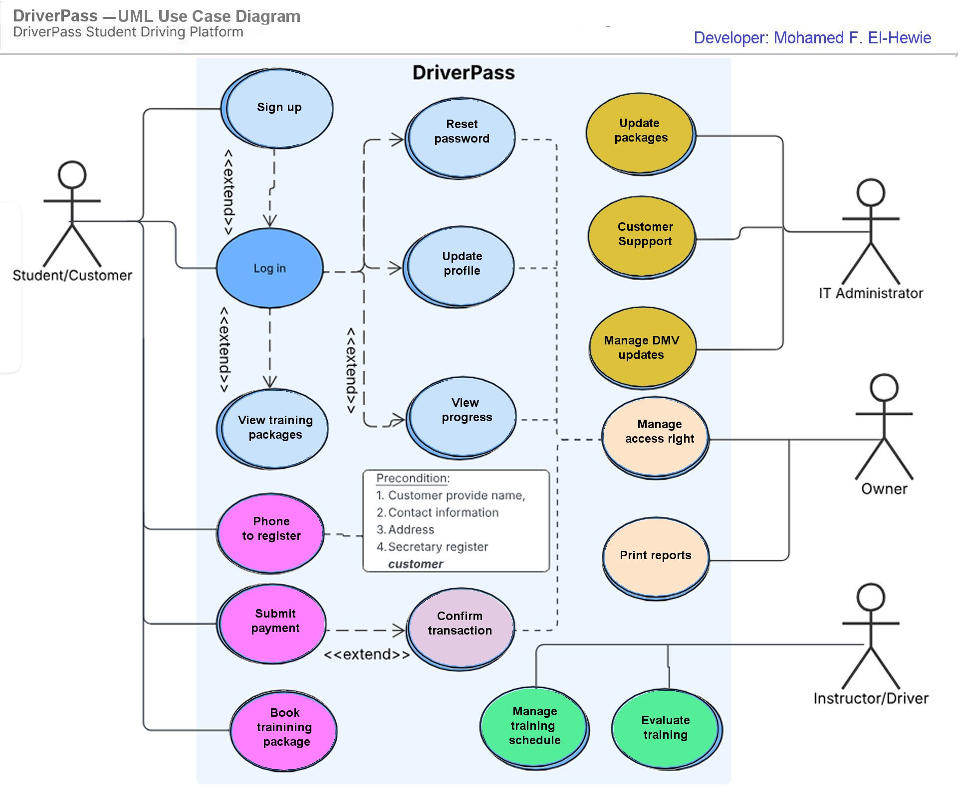
The DriverPass UML Use Case Diagram
It shows the main goals of the client by using a system box, actor stick figures, use case ovals, and connecting relationship lines.

UML Activity Diagrams

- UML Activity Diagram for “Update Customer Data” use case:

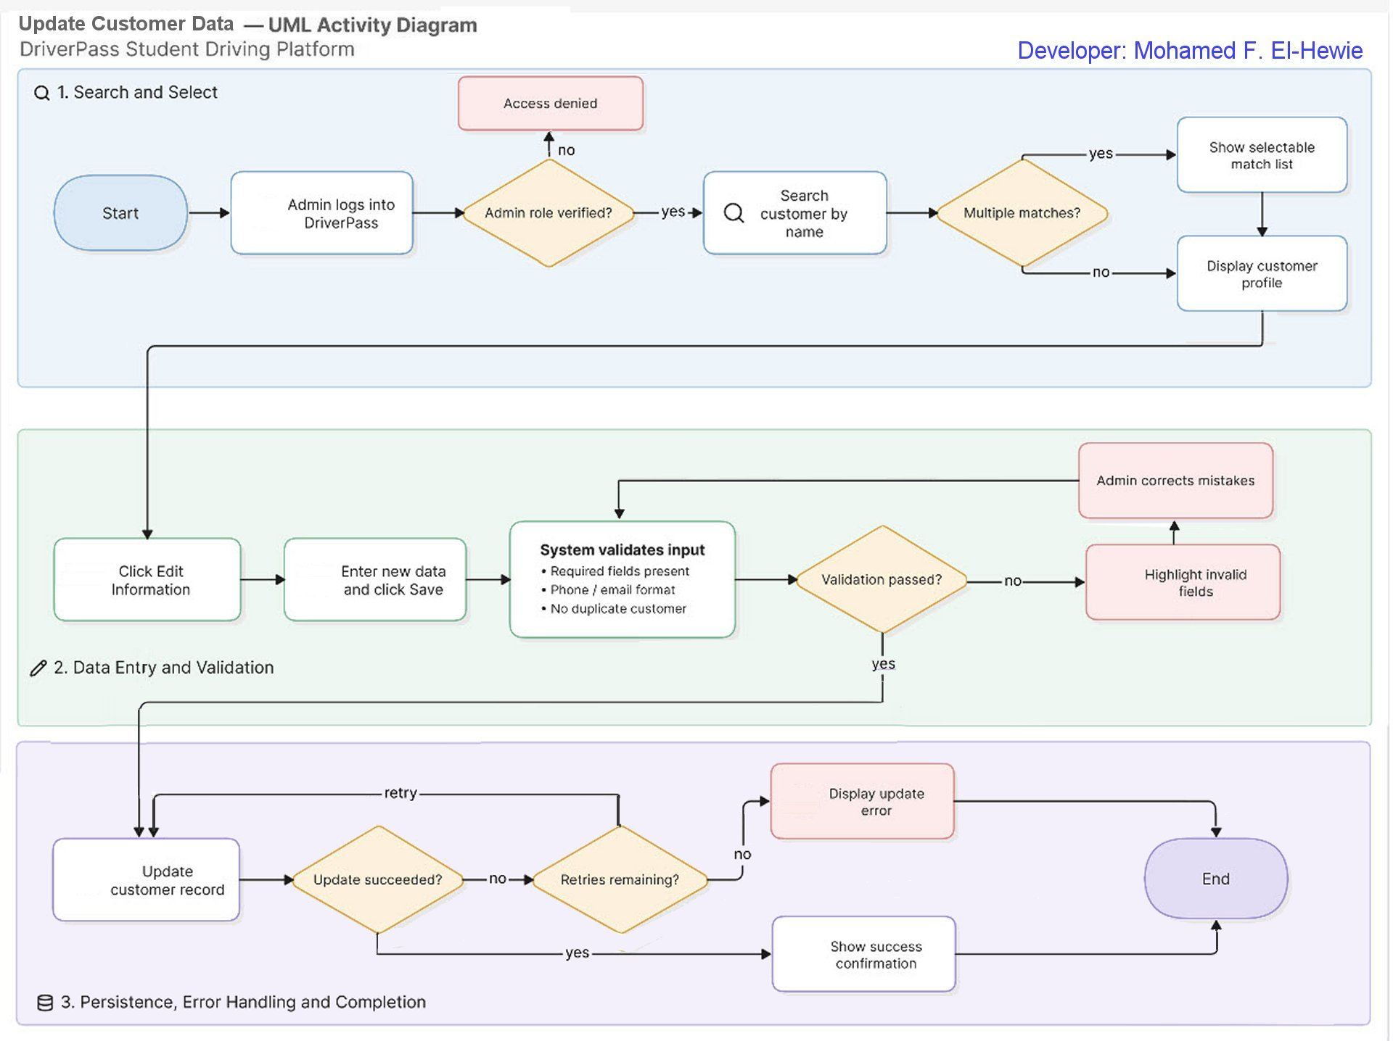

The DriverPass UML Activity Diagram for use case “Update Customer Data.”

It shows the flow of data through the three processes :
Search & Select,
Data Entry & Validation, and
Persistence, Error handling & Completion.

- UML Activity Diagram for “Register Customer” use case:

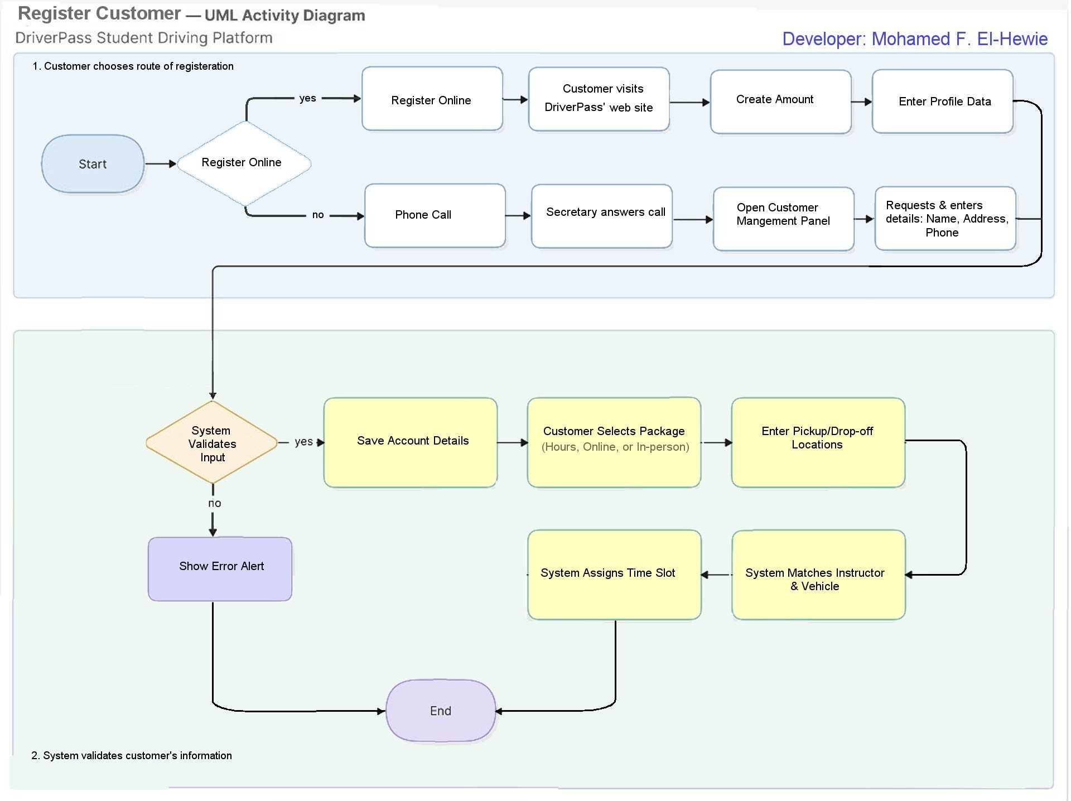

The DriverPass UML Activity Diagram for use case “Register Customer.”
It shows the flow of data through the two processes:
Choose Route of Registration and
System Validation.

UML Sequence Diagram

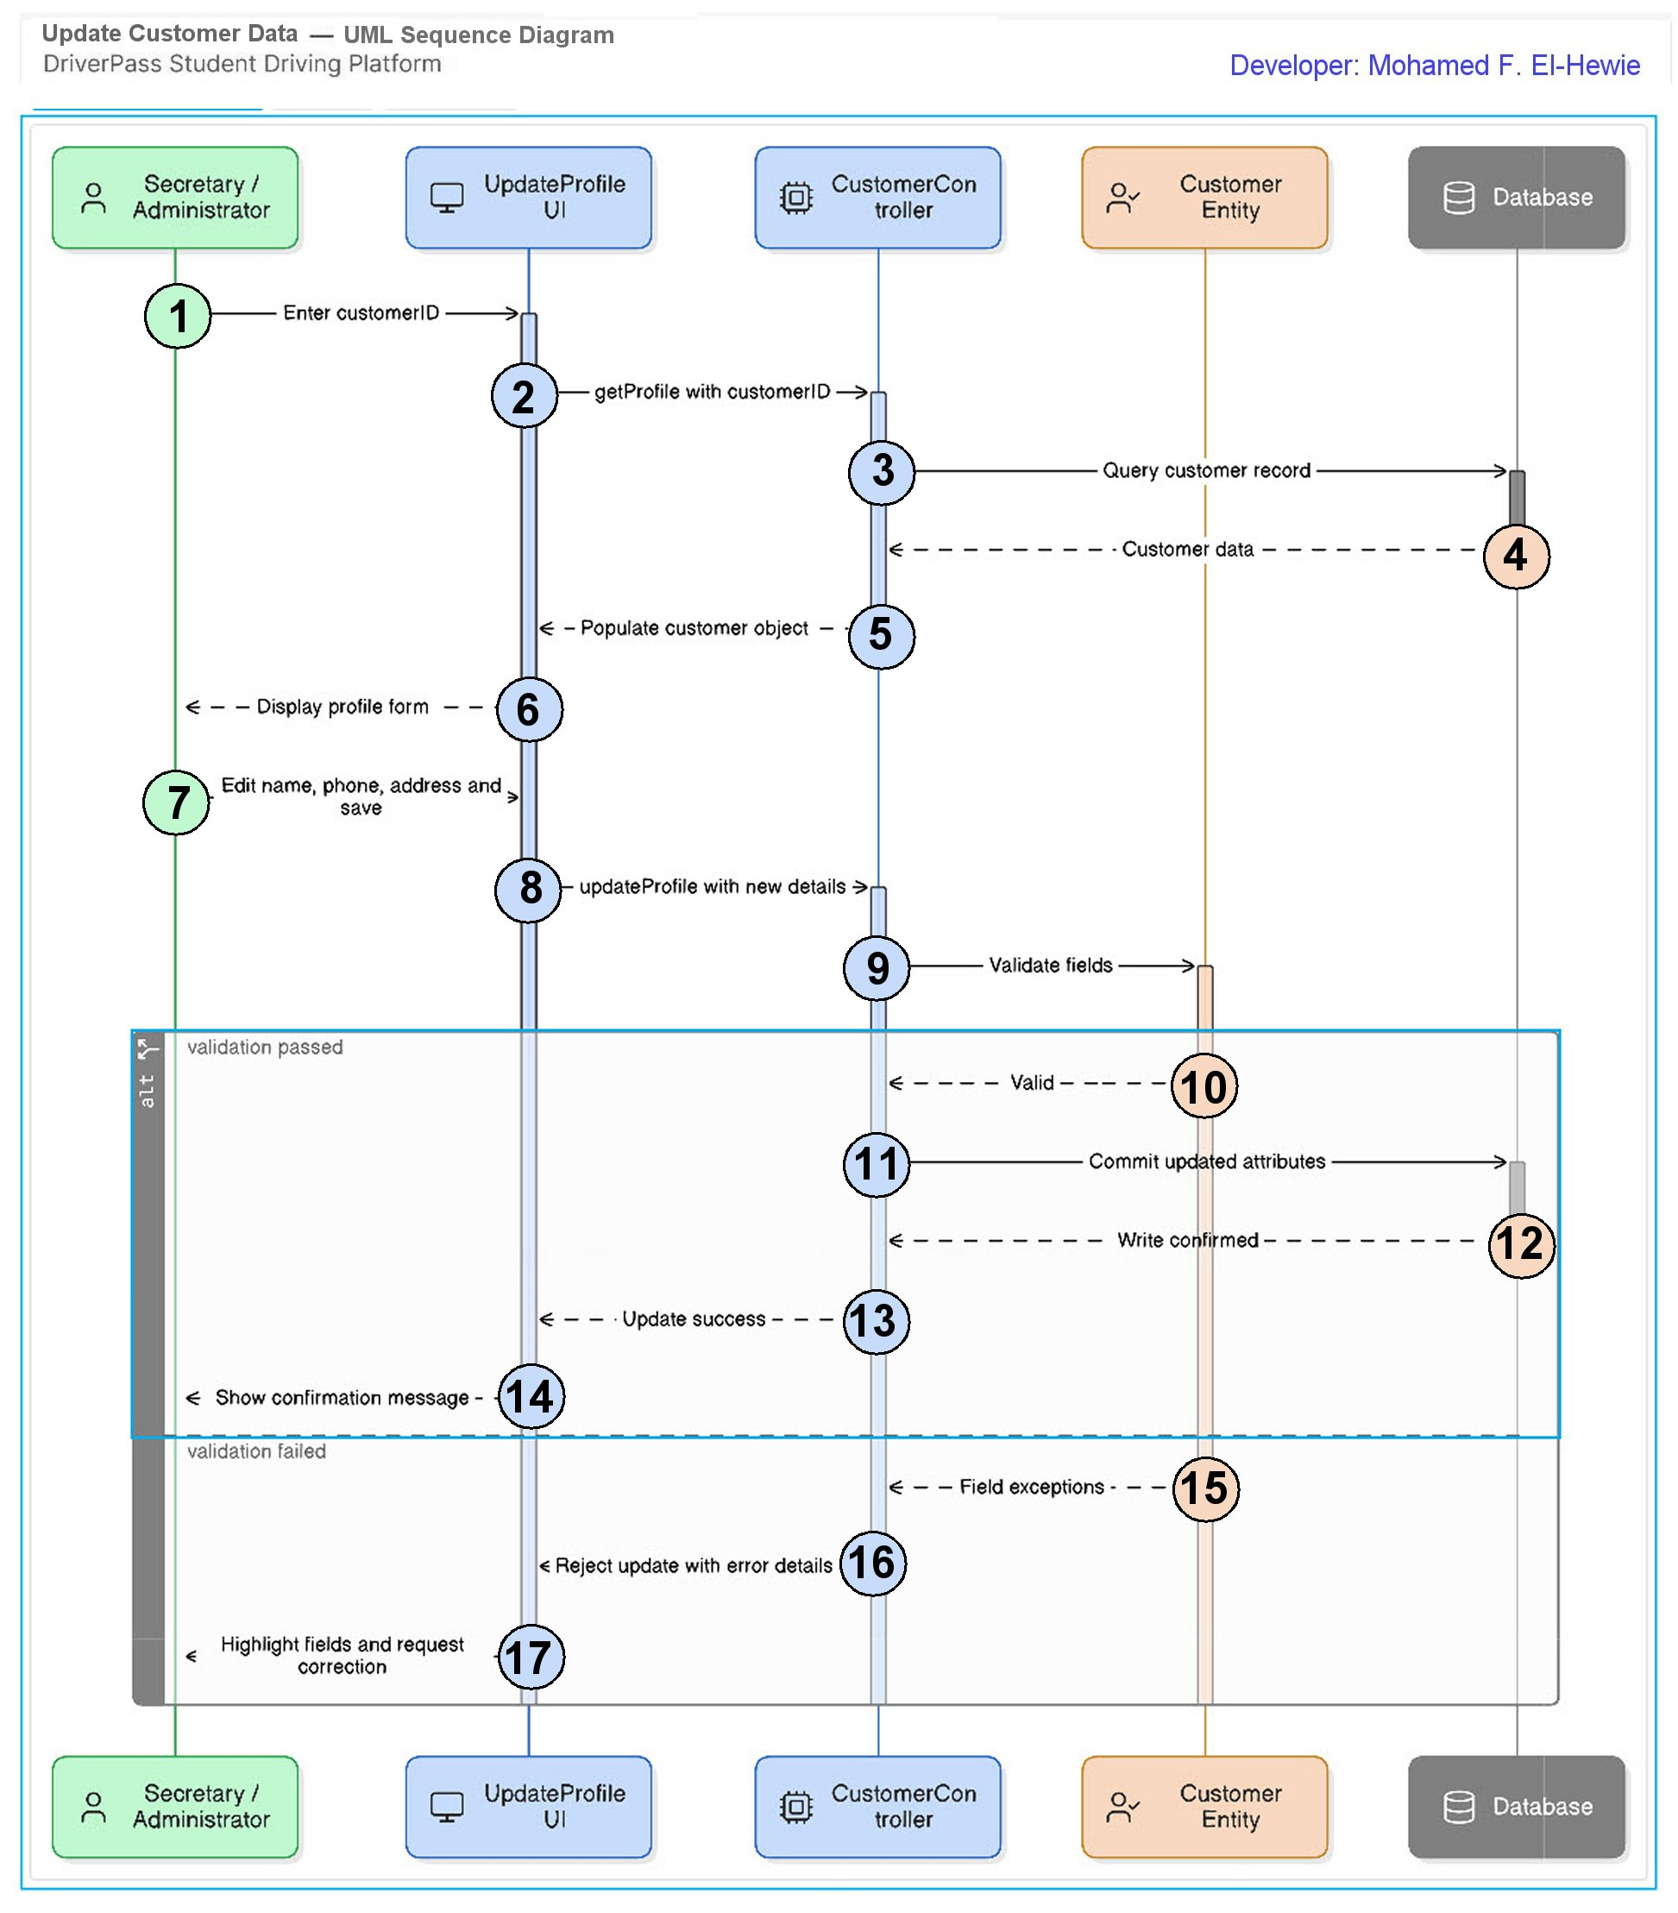

The DriverPass UML Sequence Diagram for the "Update Customer Data" use case

It illustrates 17 sequential interactions between actors and system components over time. The vertical axis depicts temporal progression, while the horizontal axis shows the direction of messages exchanged among the participating objects.

UML Class Diagram

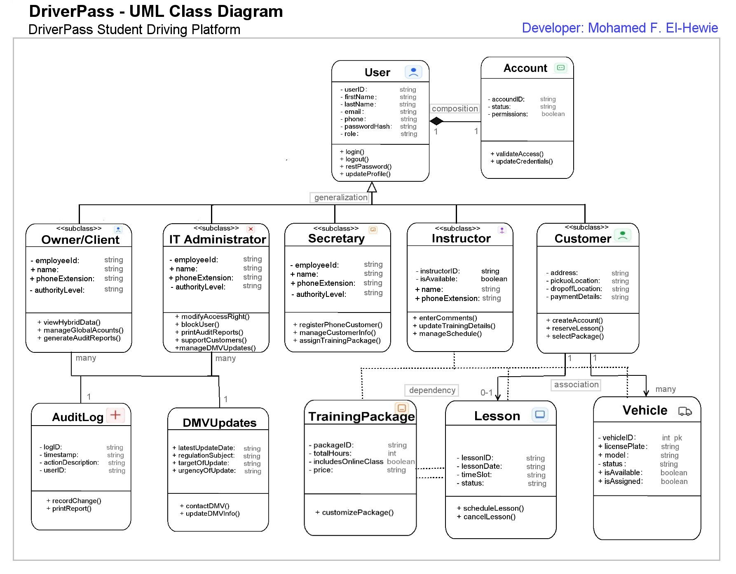
The DriverPass UML Class Diagram
It maps the project's structural objects, including their attributes, methods, and relationships. These components collaborate to execute the processes and activities required to fulfill all project requirements.

Technical Requirements

Nonfunctional Requirements

Performance Requirements:
- The system should be built as a cloud-hosted web application to eliminate local hardware dependencies, utilizing modern enterprise frameworks. It requires full cross-browser compatibility across Google Chrome, Mozilla Firefox, Safari, and Microsoft Edge.
- The system should be designed for rapid server-client request cycles, delivering key button interactions and page rendering in fewer than 100 milliseconds to ensure a seamless, real-time user experience.
- The system should operate on an ongoing deployment schedule with continuous updates (bi-weekly to monthly) to quickly patch bugs, harden security, and seamlessly integrate new regulatory updates (e.g., state DMV rules).

Platform Constraints:
- The system must be fully responsive and optimized for Google Chrome, Mozilla Firefox, Safari, and Edge to ensure a consistent cross-browser user experience.
- The system should have database to serve as the central repository for all DriverPass data structures, leveraging a managed “Platform as a Service” to offload routine backups and security maintenance from the client.

Accuracy and Precision:
  - The system should be built to identify individual users using role-based permissions. It should follow standard protocol; username inputs are case-insensitive, while passwords remain case-sensitive. Because HTTP is stateless, web and application environments issue a unique, encrypted session ID. This ID is stored in a browser cookie to tie user requests to their specific server profile, ensuring data isolation.
  - Once user’s information is authenticated, the server should map the user to their designated system role, strictly enforcing their authorized view and modification privileges.
  - The system should possess automated error logging to immediately notify administrators of events threatening system functionality, security, or data integrity.

Those alarming situations include the following:
- Repeated failed login attempts or multiple invalid account queries.
- Unauthorized or tracked changes to administrator configurations.
- Unaccounted-for application crashes that disrupt the end-user experience.
- Massive data synchronization errors that compromise overall system accuracy.

Adaptability:
- In a cloud-based web system, user accounts are managed centrally via the administrative back-end. The application evaluates an Identity and Access Management authorization layer upon any modification to a user’s role, instantly granting or revoking associated privileges in real-time without changing any code.
- The system will be using standardized APIs to decouple the front-end interface from back-end database layers. This allows modular cloud components to be updated independently without disrupting the end-user experience, while browser and OS compatibility updates are seamlessly handled via back-end patches.

IT administrators are granted full Role-Based Access Control (RBAC) oversight of system and server controls to maintain overall security and performance. This capability empowers administrators to create employee accounts, assign and modify RBAC roles, reset passwords, and disable inactive profiles.

Security:
- User Authentication requires a unique identifier—such as a username, email address, or phone number—combined with one or more of the following supporting credentials:
- Passwords or passkeys.
- Physical hardware tokens, software tokens, or SMS verification codes.
- Authenticator app pushes notifications or stored biometrics.

  - Secure data during exchange and storage as follows:
- Enforces HTTPS to protect data in transit, prevent session hijacking, and eliminate protocol downgrade vulnerabilities.
- Encrypts sensitive data stores to prevent unauthorized access to physical or logical server volumes.
- Stores all user credentials using strong, adaptive cryptographic hashing algorithms.

  - Mitigate brute-force and automated bot attacks, the system implements the following safeguards:
- Restricts the maximum number of login requests permitted from a specific IP address within a set timeframe.
- Implements a mandatory, progressively increasing time delay after each successive failed login attempt.
- Freezes accounts temporarily after 3 to 5 failed attempts, requiring a time-delay expiration or identity verification to unlock.
- Triggers human-verification prompts at the first sign of anomalous or suspicious behavior.
- Returns identical, ambiguous error messages (e.g., "Invalid username or password") for all authentication failures to prevent username enumeration.

  - Account recovery through a strict workflow, as follows:
- Sends a unique, one-time verification link or token exclusively to a pre-verified communication channel, such as the registered email address.
- Enforces a strict time-to-live (TTL) window of 15 to 30 minutes on the recovery link and invalidates it immediately upon its first use.
- Requires the user to enter the new password twice and validates it against current system complexity standards.
- Terminates all other active sessions across all devices immediately upon a successful password update to block unauthorized third-party access.

Functional Requirements

- Security Requirements:
- The system shall authenticate user login credentials.
- The system shall allow users to reset passwords via a secure, emailed link.
- The system shall temporarily lock accounts after repeated failed login attempts to prevent brute-force attacks.
- The system shall verify and enforce end-user access permissions.

- Services Requirements:
- The system shall display details of services available for purchase.
- The system shall allow customers to purchase, update, modify, or cancel online training packages.
- The system shall process and store consumer data in a secure database.

- Activity Tracking Requirements:
- The system shall allow users to track scheduled, rescheduled, and cancelled reservations.
- The system shall display student exam progress, test history, remaining requirements, and final scores.
- The system shall allow instructors and administrators to track user progress and view or print activity logs.

- Administrative Requirements:
- The system shall automate immediate notifications to IT administrators regarding critical crashes and security breaches.
- The system shall notify administrators of updates to Department of Motor Vehicles (DMV) policies, rules, and tests.
- The system shall automate the integration of new online DMV materials and test content.
- The system shall enable administrators to manage, add, or disable service packages and user accounts.

================================ END ================================

